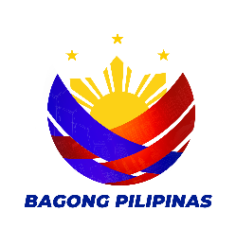
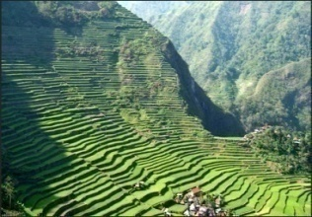
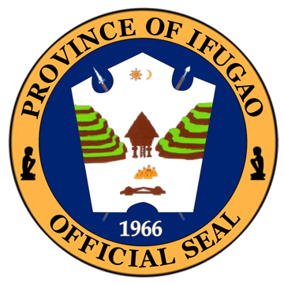
Republic of the Philippines
Cordillera Administrative Region
Provincial Local Government Unit of Ifugao
BIDS AND AWARDS COMMITTEE - INFRA
3rd Floor PEO Bldg., Capitol Compound
Lagawe, Ifugao
Email Ad.: bacinfraifugao21@gmail.com

INVITATION TO BID
Publication No. 08 - 2024- I
(Second Publication)

NAME OF CONTRACT: Package 1-2024-PB (1. Continuation of Aduyongan MPH
2. Continuation of Multi Purpose Hall at Aduyongan, Mayoyao)

LOCATION: Aduyongan, Mayoyao

- The Provincial Government of Ifugao, through the 2023-20% DF intends to apply the sum of One Million Four Hundred Sixty Nine Thousand Two Hundred Ninety Four Pesos & 71/100 (PhP 1,469,294.71) being the Approved Budget for the Contract (ABC) to payments under the contract for Publication No. 08 - 2024- I (Second Publication). Bids received in excess of the ABC shall be automatically rejected at bid opening. See attached “Annex A” for other information.

- The Provincial Government of Ifugao now invites bids for the above Procurement Project. Completion of the Works is required within 80 Calendar Days. Bidders should have completed a contract similar to the Project. The description of an eligible bidder is contained in the Bidding Documents, particularly, in Section II (Instructions to Bidders).

- Bidding will be conducted through open competitive bidding procedures using non-discretionary “pass/fail” criterion as specified in the 2016 revised Implementing Rules and Regulations (IRR) of Republic Act (RA) No. 9184.

- Interested bidders may obtain further information from the Bids and Awards Committee Office of the Provincial Government of Ifugao and inspect the Bidding Documents at the address given below from 8:00 AM to 5:00 PM, Monday to Friday.

- A complete set of Bidding Documents may be acquired by interested bidders on April 2, 2024 to April 23, 2024 at the BAC Office, 3rd Floor, PEO Building, Capitol Compound, Lagawe, Ifugao and upon payment of the applicable fee for the Bidding Documents, pursuant to the latest Guidelines issued by the GPPB, in the amount of Five Thousand Pesos Only (Php 5,000.00) at the Provincial Treasury Office. The Procuring Entity shall allow the bidder to present its proof of payment for the fees in person.

- The Provincial Government of Ifugao through its Bids and Awards Committee will hold a Pre-Bid Conference on April 11, 2024 at 1:30 P.M. at the Bids and Awards Committee (BAC) Office, 3rd Floor, PEO Building, Capitol Compound, Lagawe, Ifugao, which shall be open to prospective bidders.

- Bids must be duly received by the BAC Secretariat through, manual submission at the office address as indicated below, on or before April 23, 2024 at 1:00 P.M. at the Bids and Awards Committee (BAC) Office, 3rd Floor, PEO Building, Capitol Compound, Lagawe, Ifugao. Late bids shall not be accepted.
- All bids must be accompanied by a bid security in any of the acceptable forms and in the amount stated in ITB Clause 15.

- Bid opening shall be on April 23, 2024 at 2:00 P.M. basing on the BAC Wall Clock at the Bids and Awards Committee (BAC) Office, 3rd Floor, PEO Building, Capitol Compound, Lagawe, Ifugao. Bids will be opened in the presence of the bidders’ representatives who choose to attend the activity.

- The Provincial Government of Ifugao reserves the right to reject any and all bids, declare a failure of bidding, or not award the contract at any time prior to contract award in accordance with Sections 35.6 and 41 of the 2016 revised Implementing Rules and Regulations (IRR) of RA No. 9184, without thereby incurring any liability to the affected bidder or bidders.

- For further information, please refer to:

BAC Secretariat
Bids and Awards Committee (BAC) Office
3rd Floor, PEO Building, Capitol Compound,
Poblacion South, Lagawe, Ifugao
bacinfraifugao21@gmail.com
63-0965-407-3198

Date of Issue: April 2, 2024

CARMELITA B. BUYUCCAN

BAC Chairperson

ANNEX “A”
Publication Number | Publication No. 08 - 2024- I (Second Publication)
Name of Contract | Package 1-2024-PB (1. Continuation of Aduyongan MPH 2. Continuation of Multi Purpose Hall at Aduyongan, Mayoyao)
Location | Aduyongan, Mayoyao
Source of Fund | 2023-20% DF
Approved Budget for The Contract (ABC) | PhP 1,469,294.71
Contract Duration | 80 Calendar Days
Minimum Required Equipment | 1 Unit Plate Compactor (5Hp)  1 Unit One Bagger Concrete Mixer  1 Unit Welding Machine  1 Unit Baby Grinder
Major Items of Work | CHB Non Load Bearing (100mm thk.,including reinforcing steel), Unglazed Tiles, Cement Plaster Finish, Septic Vault (Concrete/CHB), Residential Casement Steel Windows, Doors (Wooden Panel), Electrical Works, Glazed Tiles, Plumbing Fixtures, Railing, Aluminum Framed Glass Door (Swing Type) and Structural Concrete (Footings & Slabs on Fill, Class “A”, 28 days)
Cost of Bid Documents | PhP 5,000.00

Prepared By:
ALJETTE P. BINLINGAN
BAC Secretariat

Certified Correct By:

ARUNDALE GUM-U I. BUNNAG
BAC Secretariat (Goods & Infra)

